**Task 1 - Getting started with moqups.com account setup and tools overview**

1. Create a free account in moqups.com. Follow with the click on the a Create a Free Account. You can get this screen. Let’s go with Sign up with Google.

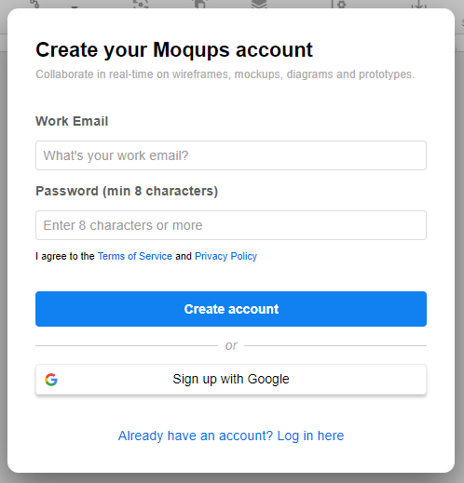

1. You will see this screen. Select Blank Project & Rename as “Wireframe & Mockup”

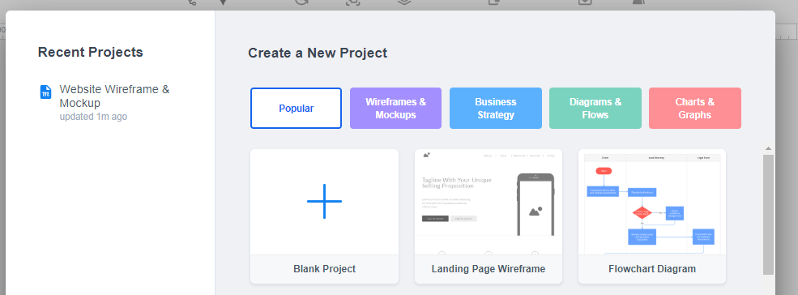

1. You will see this screen

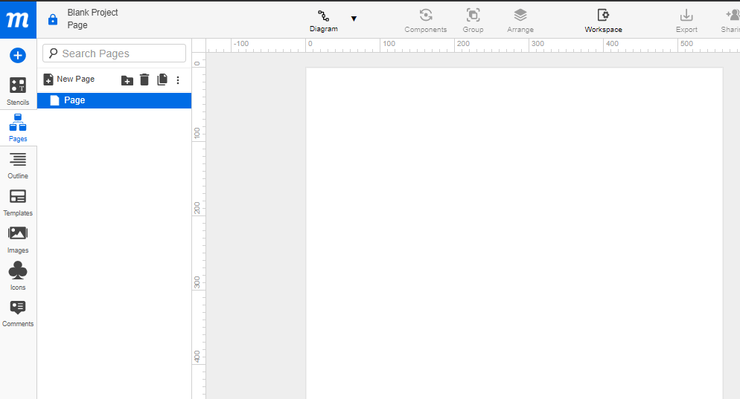

1. Check for components/icons at left side:
   1. Stencils
   2. Pages
   3. Images
2. **Pages Icon:** How to work on Page Setting?
   1. Select Pages
   2. Select Page

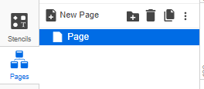

* 1. Right Click on Page > Rename. Now let’s Rename as “Wireframe1”
  2. Right Click > Page Settings. Set Width of 800 and Height of 700

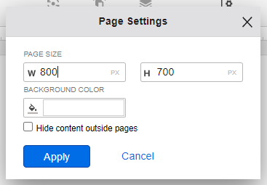

1. Check what is there for you in **Stencils Icon**
2. Drag and drop some of the objects in Stencils that you can use to create wireframe. Do not limit with what is just mentioned below.
   1. Rectangle
   2. Link
   3. Heading
   4. Paragraph
   5. Image Placeholder
   6. Banner
   7. Search
   8. Menus & Navigation
   9. Form Controls
   10. Table
   11. Calendar
   12. Map and
   13. Others you can use

­

**Task 2 – Design the below like wireframe structure. Use your own creativity.**

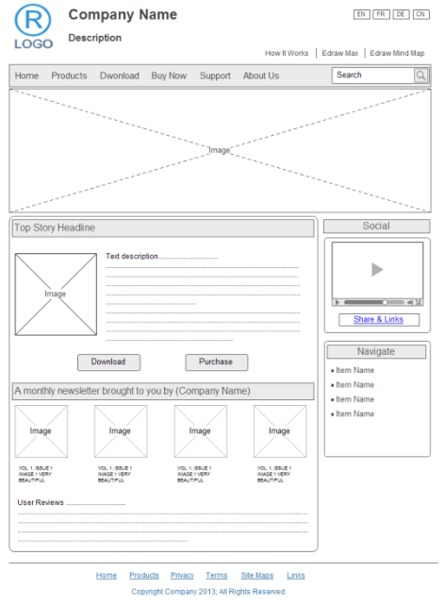

**Task 3 – Create a mockup design like your college website’s contact us page. Use your own creativity for this design.**

